

University of Southeastern Philippines

Bo. Obrero,

**Concept Map**

Adults

Kids

Discounted

Unmonitored Sales

Lacks Data Gathering

Pools

Entrance fee

INCLUDES

Weekly

Annually

Monthly

Daily

INCLUDES

Accommodation

INCLUDES

Rides

No. of Total Guests

INCLUDES

HELPS TO ANSWER

NECESSARY FOR

NEEDED TO ANSWER

REPRESENTS

Revenue

Data Gathering

POINT OF SALES

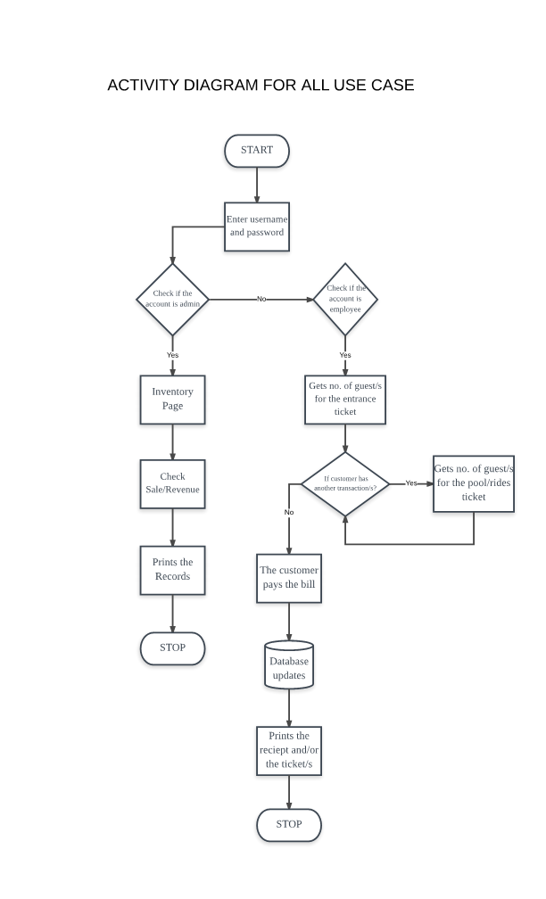

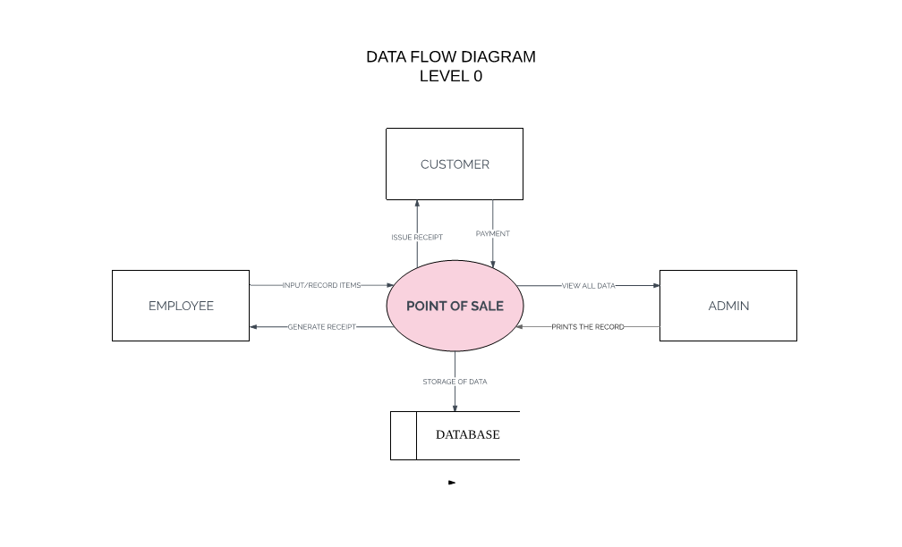

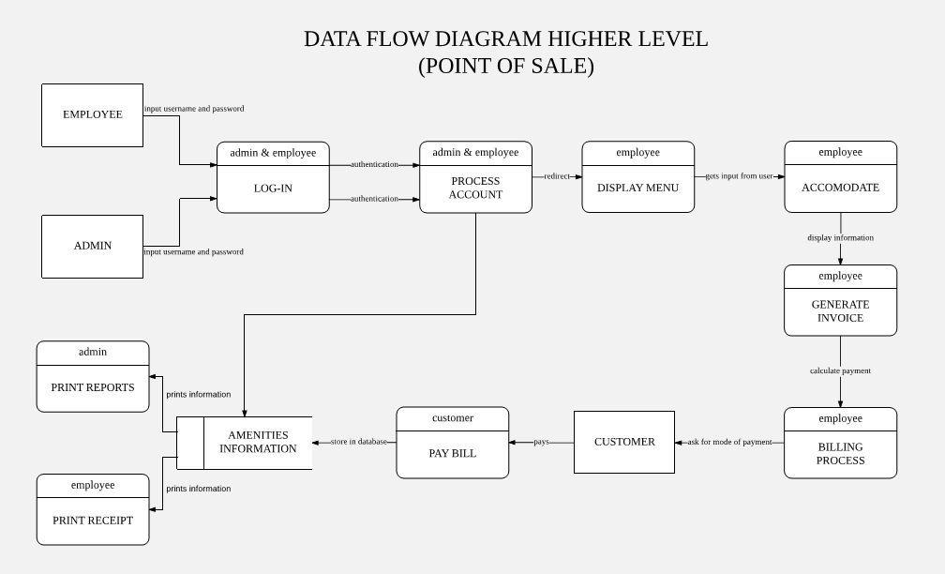

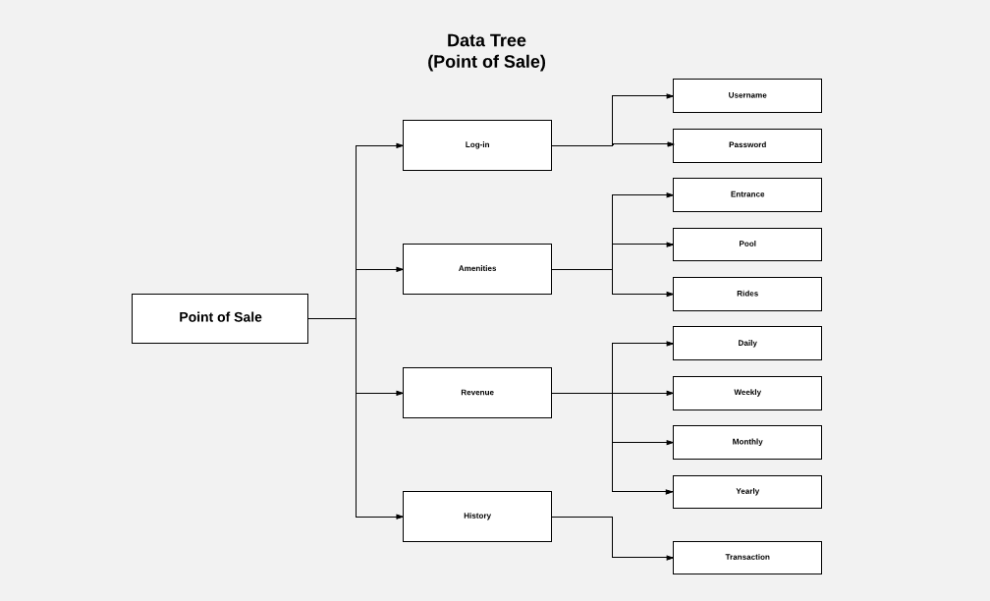

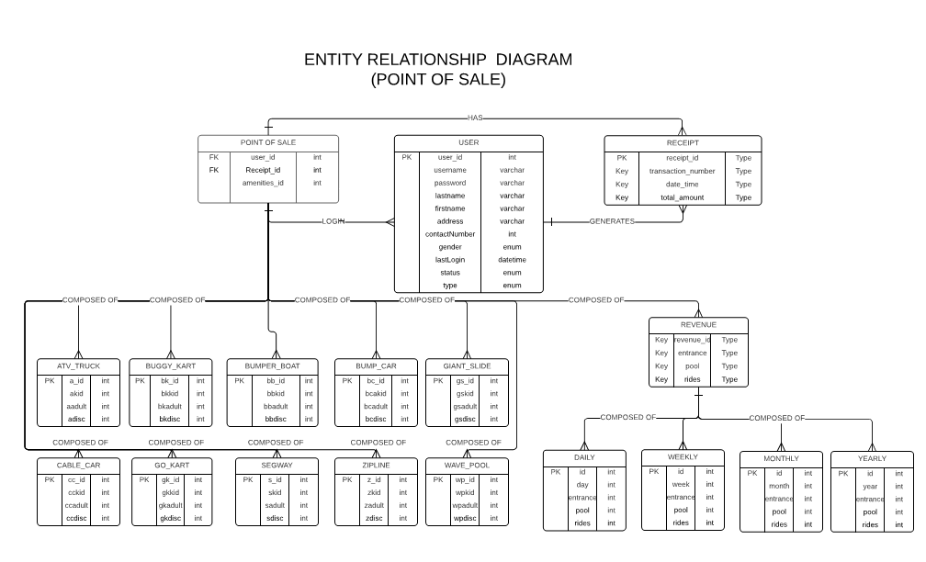

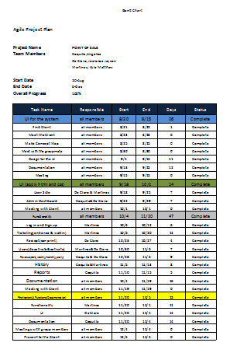

**DEPLOYMENT DIAGRAM**

**(CONFIGURATION MODEL)**

**<<DEVICE>>**

**DATABASE LOCAL HOST SERVER**

<<ARTIFACT>>

WEBSITE

**<<DEVICE>>**

**WEB LOCAL HOST SERVER**

<<ARTIFACT>>

MY SQL DATABASE

**<<DEVICE>>**

**EMPLOYEE**

<<DEVICE>>

BROWSER

<<ARTIFACT>>

HTML5 AND CSS3